What is RDBMS?
RDBMS stands for Relational Database Management System. RDBMS is the basis for SQL, and for all modern database systems like MS SQL Server, IBM DB2, Oracle, MySQL, and Microsoft Access.
A Relational database management system (RDBMS) is a database management system (DBMS) that is based on the relational model as introduced by E. F. Codd.

What is a table?
The data in an RDBMS is stored in database objects which are called as tables. This table is basically a collection of related data entries and it consists of numerous columns and rows.
Remember, a table is the most common and simplest form of data storage in a relational database. The following program is an example of a CUSTOMERS table −
+----+----------+-----+-----------+----------+
| ID | NAME | AGE | ADDRESS | SALARY |
+----+----------+-----+-----------+----------+
|1|Ramesh|32|Ahmedabad|2000.00|
|2|Khilan|25|Delhi|1500.00|
|3|kaushik|23|Kota|2000.00|
|4|Chaitali|25|Mumbai|6500.00|
|5|Hardik|27|Bhopal|8500.00|
|6|Komal|22| MP |4500.00|
|7|Muffy|24|Indore|10000.00|
+----+----------+-----+-----------+----------+

What is a field/Attribute?
Every table is broken up into smaller entities called fields. The fields in the CUSTOMERS table consist of ID, NAME, AGE, ADDRESS and SALARY.
A field is a column in a table that is designed to maintain specific information about every record in the table.

What is a Record or a Row?
A record is also called as a row of data is each individual entry that exists in a table. For example, there are 7 records in the above CUSTOMERS table. Following is a single row of data or record in the CUSTOMERS table −
+----+----------+-----+-----------+----------+
|1|Ramesh|32|Ahmedabad|2000.00|
+----+----------+-----+-----------+----------+
A record is a horizontal entity in a table.

What is a column?
A column is a vertical entity in a table that contains all information associated with a specific field in a table.
For example, a column in the CUSTOMERS table is ADDRESS, which represents location description and would be as shown below −
+-----------+
| ADDRESS |
+-----------+
|Ahmedabad|
|Delhi|
|Kota|
|Mumbai|
|Bhopal|
| MP |
|Indore|
+----+------+

What is a NULL value?
A NULL value in a table is a value in a field that appears to be blank, which means a field with a NULL value is a field with no value.
It is very important to understand that a NULL value is different than a zero value or a field that contains spaces. A field with a NULL value is the one that has been left blank during a record creation.

SQL Constraints
Constraints are the rules enforced on data columns on a table. These are used to limit the type of data that can go into a table. This ensures the accuracy and reliability of the data in the database.
Constraints can either be column level or table level. Column level constraints are applied only to one column whereas, table level constraints are applied to the entire table.
Following are some of the most commonly used constraints available in SQL −
- NOT NULL Constraint − Ensures that a column cannot have a NULL value.
- DEFAULT Constraint − Provides a default value for a column when none is specified.
- UNIQUE Constraint − Ensures that all the values in a column are different.
- PRIMARY Key Constraint− Uniquely identifies each row/record in a database table.

- FOREIGN Key Constraint− Uniquely identifies a row/record in any another database table.
- CHECK Constraint − The CHECK constraint ensures that all values in a column satisfy certain conditions.
- INDEX − Used to create and retrieve data from the database very quickly.

Data Integrity
The following categories of data integrity exist with each RDBMS −
- Entity Integrity − There are no duplicate rows in a table.
- Domain Integrity − Enforces valid entries for a given column by restricting the type, the format, or the range of values.
- Referential integrity − Rows cannot be deleted, which are used by other records.
- User-Defined Integrity − Enforces some specific business rules that do not fall into entity, domain or referential integrity.

Integrity Constraints
- Integrity constraints are a set of rules. It is used to maintain the quality of information.
- Integrity constraints ensure that the data insertion, updating, and other processes have to be performed in such a way that data integrity is not affected.
- Thus, integrity constraint is used to guard against accidental damage to the database.

Types of Integrity Constraint
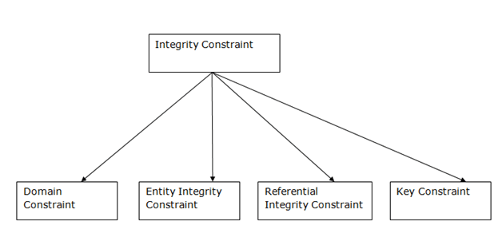

1. Domain constraints
- Domain constraints can be defined as the definition of a valid set of values for an attribute.
- The data type of domain includes string, character, integer, time, date, currency, etc. The value of the attribute must be available in the corresponding domain.
Example:
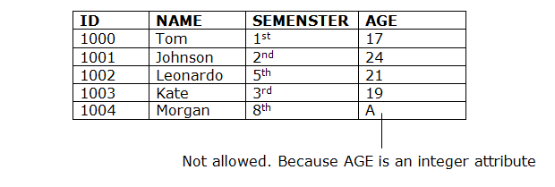

2. Entity integrity constraints
- The entity integrity constraint states that primary key value can't be null.
- This is because the primary key value is used to identify individual rows in relation and if the primary key has a null value, then we can't identify those rows.
- A table can contain a null value other than the primary key field.
Example:
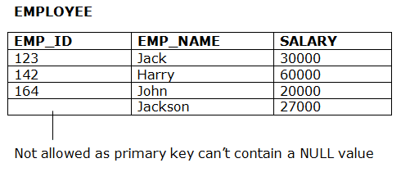

3. Referential Integrity Constraints
- A referential integrity constraint is specified between two tables.
- In the Referential integrity constraints, if a foreign key in Table 1 refers to the Primary Key of Table 2, then every value of the Foreign Key in Table 1 must be null or be available in Table 2.
Example:
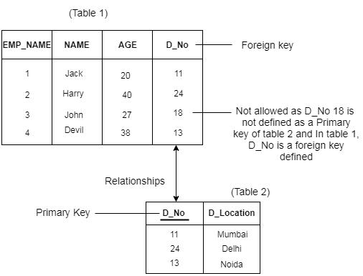

4. Key constraints
- Keys are the entity set that is used to identify an entity within its entity set uniquely.
- An entity set can have multiple keys, but out of which one key will be the primary key. A primary key can contain a unique and null value in the relational table.
Example:
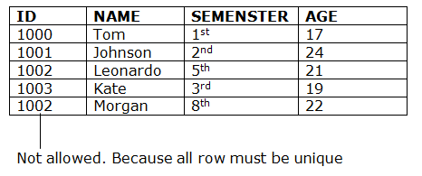

Disjoint VS Overlapping Constraint
- In disjoint constraint, an entity cannot belong to more than one lower-level entity sets.
- In overlapping constraint, same entity can belong to more than one lower-level entity sets. For example: a manager can participate in more than one project.
- Example: Consider a super class 'musician'. Two sub classes are 'singer' and 'guitar player'.
In disjoint constraint, you have to put musician in any one sub classes. In overlapping constraint, the musician can be put in both.

The disjoint rule states an entity instance of a supertype can only be a member of one subtype. The overlap rule states an entity instance of a supertype can be a member of multiple subtypes.
Example of disjoint rule: Instance of Super-type Animal can only be member of exactly one of these Sub-types being Panda, Cheetah and Dog Disjoint Union , (An animal can either be Panda or be Dog or be Cheetah but can't be any two or more at the same time)
Example of overlap rule: Instance of Super-type Person can be member of multiple Sub-types being Woman, Driver and Engineer Overlapping Union , (A person can be a Woman and that same Woman can be Driver and that same Woman can be Engineer at the same time)

Difference between DBMS and RDBMS
Although DBMS and RDBMS both are used to store information in physical database but there are some remarkable differences between them.
The main differences between DBMS and RDBMS are given below:
No. | DBMS | RDBMS
1) | DBMS applications store data as file. | RDBMS applications store data in a tabular form.
2) | In DBMS, data is generally stored in either a hierarchical form or a navigational form. | In RDBMS, the tables have an identifier called primary key and the data values are stored in the form of tables.
3) | Normalization is not present in DBMS. | Normalization is present in RDBMS.
4) | DBMS does not apply any security with regards to data manipulation. | RDBMS defines the integrity constraint for the purpose of ACID (Atomocity, Consistency, Isolation and Durability) property.
5) | DBMS uses file system to store data, so there will be no relation between the tables. | in RDBMS, data values are stored in the form of tables, so a relationship between these data values will be stored in the form of a table as well.
6) | DBMS has to provide some uniform methods to access the stored information. | RDBMS system supports a tabular structure of the data and a relationship between them to access the stored information.
7) | DBMS does not support distributed database. | RDBMS supports distributed database.
8) | DBMS is meant to be for small organization and deal with small data. it supports single user. | RDBMS is designed to handle large amount of data. it supports multiple users.
9) | Examples of DBMS are file systems, xml etc. | Example of RDBMS are mysql, postgre, sql server, oracle etc.

After observing the differences between DBMS and RDBMS, you can say that RDBMS is an extension of DBMS. There are many software products in the market today who are compatible for both DBMS and RDBMS. Means today a RDBMS application is DBMS application and vice-versa.

Codd's Rule for Relational DBMS
E.F Codd was a Computer Scientist who invented the Relational model for Database management. Based on relational model, the Relational database was created. Codd proposed 13 rules popularly known as Codd's 12 rules to test DBMS's concept against his relational model. Codd's rule actualy define what quality a DBMS requires in order to become a Relational Database Management System(RDBMS). Till now, there is hardly any commercial product that follows all the 13 Codd's rules. Even Oracle follows only eight and half(8.5) out of 13. The Codd's 12 rules are as follows.

Rule zero
This rule states that for a system to qualify as an RDBMS, it must be able to manage database entirely through the relational capabilities.

Rule 1: Information rule
All information(including metadata) is to be represented as stored data in cells of tables. The rows and columns have to be strictly unordered.

Rule 2: Guaranted Access
Each unique piece of data(atomic value) should be accesible by : Table Name + Primary Key(Row) + Attribute(column).
NOTE: Ability to directly access via POINTER is a violation of this rule.

Rule 3: Systematic treatment of NULL
Null has several meanings, it can mean missing data, not applicable or no value. It should be handled consistently. Also, Primary key must not be null, ever. Expression on NULL must give null.

Rule 4: Active Online Catalog
Database dictionary(catalog) is the structure description of the complete Database and it must be stored online. The Catalog must be governed by same rules as rest of the database. The same query language should be used on catalog as used to query database.

Rule 5: Powerful and Well-Structured Language
One well structured language must be there to provide all manners of access to the data stored in the database. Example: SQL, etc. If the database allows access to the data without the use of this language, then that is a violation.

Rule 6: View Updation Rule
All the view that are theoretically updatable should be updatable by the system as well.

Rule 7: Relational Level Operation
There must be Insert, Delete, Update operations at each level of relations. Set operation like Union, Intersection and minus should also be supported.

Rule 8: Physical Data Independence
The physical storage of data should not matter to the system. If say, some file supporting table is renamed or moved from one disk to another, it should not effect the application.

Rule 9: Logical Data Independence
If there is change in the logical structure(table structures) of the database the user view of data should not change. Say, if a table is split into two tables, a new view should give result as the join of the two tables. This rule is most difficult to satisfy.

Rule 10: Integrity Independence
The database should be able to enforce its own integrity rather than using other programs. Key and Check constraints, trigger etc, should be stored in Data Dictionary. This also make RDBMS independent of front-end.

Rule 11: Distribution Independence
A database should work properly regardless of its distribution across a network. Even if a database is geographically distributed, with data stored in pieces, the end user should get an impression that it is stored at the same place. This lays the foundation of distributed database.

Rule 12: Nonsubversion Rule
If low level access is allowed to a system it should not be able to subvert or bypass integrity rules to change the data. This can be achieved by some sort of looking or encryption.

Introduction to Database Keys
Keys are very important part of Relational database model. They are used to establish and identify relationships between tables and also to uniquely identify any record or row of data inside a table.
A Key can be a single attribute or a group of attributes, where the combination may act as a key.

What is a Relation Key?
A relation key is an attribute which can uniquely identify a particular tuple(row) in a relation(table).

Relational Integrity Constraints
Every relation in a relational database model should abide by or follow a few constraints to be a valid relation, these constraints are called as Relational Integrity Constraints.
The three main Integrity Constraints are:
- Key Constraints
- Domain Constraints
- Referential integrity Constraints

Key Constraints
We store data in tables, to later access it whenever required. In every table one or more than one attributes together are used to fetch data from tables. The Key Constraintspecifies that there should be such an attribute(column) in a relation(table), which can be used to fetch data for any tuple(row).
The Key attribute should never be NULL or same for two different row of data.
For example, in the Employee table we can use the attribute ID to fetch data for each of the employee. No value of ID is null and it is unique for every row, hence it can be our Key attribute.

Domain Constraint
Domain constraints refers to the rules defined for the values that can be stored for a certain attribute.
Like we explained above, we cannot store Address of employee in the column for Name.
Similarly, a mobile number cannot exceed 10 digits.

Why we need a Key?
In real world applications, number of tables required for storing the data is huge, and the different tables are related to each other as well.
Also, tables store a lot of data in them. Tables generally extends to thousands of records stored in them, unsorted and unorganised.
Now to fetch any particular record from such dataset, you will have to apply some conditions, but what if there is duplicate data present and every time you try to fetch some data by applying certain condition, you get the wrong data. How many trials before you get the right data?
To avoid all this, Keys are defined to easily identify any row of data in a table.
Let's try to understand about all the keys using a simple example.

student_id | name | phone | age
1 | Akon | 9876723452 | 17
2 | Akon | 9991165674 | 19
3 | Bkon | 7898756543 | 18
4 | Ckon | 8987867898 | 19
5 | Dkon | 9990080080 | 17
Let's take a simple Student table, with fields student_id, name, phone and age.

Super Key
Super Key is defined as a set of attributes within a table that can uniquely identify each record within a table. Super Key is a superset of Candidate key.In the table defined above super key would include student_id, (student_id, name), phone etc.
Confused? The first one is pretty simple as student_id is unique for every row of data, hence it can be used to identity each row uniquely.Next comes, (student_id, name), now name of two students can be same, but their student_id can't be same hence this combination can also be a key.Similarly, phone number for every student will be unique, hence again, phone can also be a key.
So they all are super keys.

Candidate Key
Candidate keys are defined as the minimal set of fields which can uniquely identify each record in a table. It is an attribute or a set of attributes that can act as a Primary Key for a table to uniquely identify each record in that table. There can be more than one candidate key.
In our example, student_id and phone both are candidate keys for table Student.
- A candiate key can never be NULL or empty. And its value should be unique.
- There can be more than one candidate keys for a table.
- A candidate key can be a combination of more than one columns(attributes).

Primary Key
Primary key is a candidate key that is most appropriate to become the main key for any table. It is a key that can uniquely identify each record in a table.
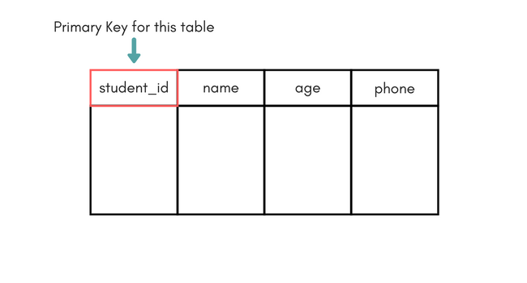
For the table Student we can make the student_id column as the primary key.

Composite Key
Key that consists of two or more attributes that uniquely identify any record in a table is called Composite key. But the attributes which together form the Composite key are not a key independentely or individually.
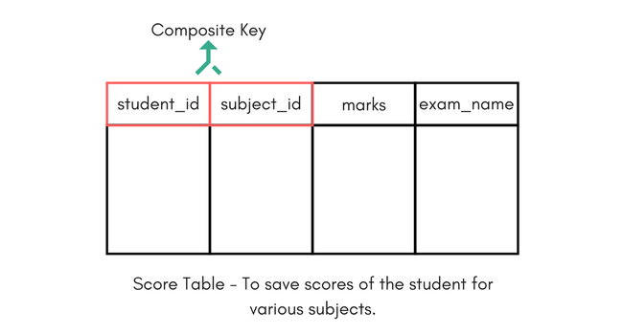
In the above picture we have a Score table which stores the marks scored by a student in a particular subject.
In this table student_id and subject_id together will form the primary key, hence it is a composite key.

Secondary or Alternative key
The candidate key which are not selected as primary key are known as secondary keys or alternative keys.

Non-key Attributes
Non-key attributes are the attributes or fields of a table, other than candidate keyattributes/fields in a table.

Non-prime Attributes
Non-prime Attributes are attributes other than Primary Key attribute(s)..

Database Schema
A database schema is the skeleton structure that represents the logical view of the entire database. It defines how the data is organized and how the relations among them are associated. It formulates all the constraints that are to be applied on the data.
A database schema defines its entities and the relationship among them. It contains a descriptive detail of the database, which can be depicted by means of schema diagrams. It’s the database designers who design the schema to help programmers understand the database and make it useful.
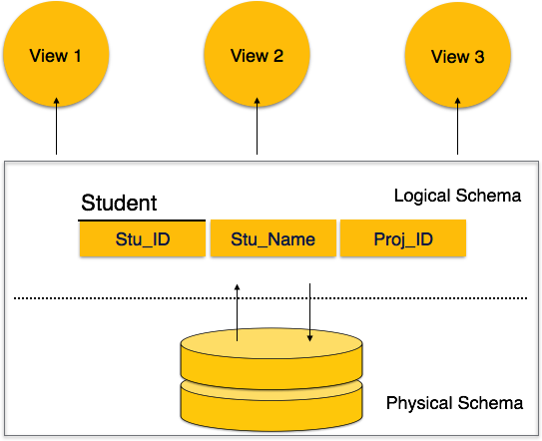
A database schema can be divided broadly into two categories −
- Physical Database Schema − This schema pertains to the actual storage of data and its form of storage like files, indices, etc. It defines how the data will be stored in a secondary storage.
- Logical Database Schema − This schema defines all the logical constraints that need to be applied on the data stored. It defines tables, views, and integrity constraints.

Database Instance
It is important that we distinguish these two terms individually. Database schema is the skeleton of database. It is designed when the database doesn't exist at all. Once the database is operational, it is very difficult to make any changes to it. A database schema does not contain any data or information.
A database instance is a state of operational database with data at any given time. It contains a snapshot of the database. Database instances tend to change with time. A DBMS ensures that its every instance (state) is in a valid state, by diligently following all the validations, constraints, and conditions that the database designers have imposed.

What is a Database Schema?

In database terms, a schema (pronounced “skee-muh” or “skee-mah”) is the organisation and structure of a database. Both schemas and schemata can be used as plural forms.
A schema contains schema objects, which could be tables, columns, data types, views, stored procedures, relationships, primary keys, foreign keys, etc.
A database schema can be represented in a visual diagram, which shows the database objects and their relationship with each other.
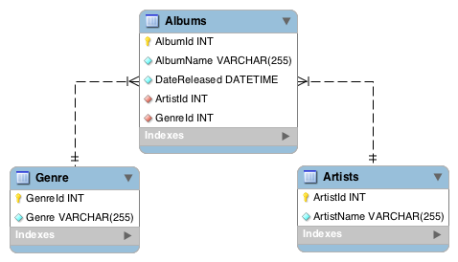
A basic schema diagram representing a small three-table database.
Above is a simple example of a schema diagram. It shows three tables, along with their data types, relationships between the tables, as well as their primary keys and foreign keys.
Here is a more complex example of a database schema:
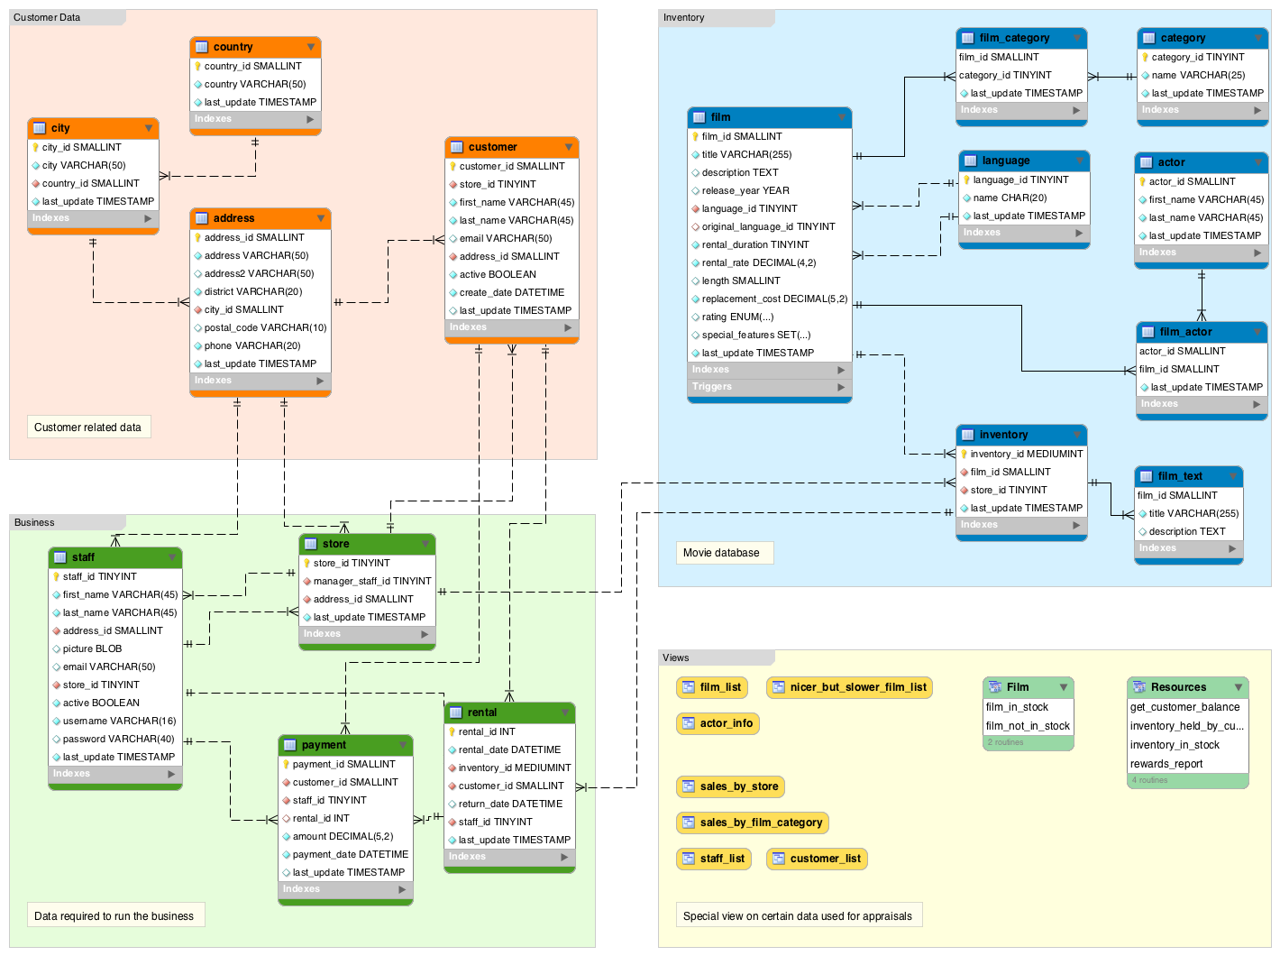
A database schema diagram of the Sakila Sample Database.
In this case, the schema diagram has been separated into four sections:
- Customer Data: Data related to the customers, such as their name, address, etc
- Business: Data required to run the business, such as staff, store locations, payment details, etc
- Inventory: Details on all products. In this case the products are movies, so it contains data such as movie title, its category, the actors, etc.
- Views: Special view on data used for appraisals.
So by looking at these schema diagrams, we could go ahead and create a database. In fact, MySQL Workbench allows you to generate a CREATE TABLE script straight from the diagram. You can then use the script to create a database. You can even reverse engineer a database into a diagram.

Is a Schema and a Database the Same Thing?
There’s a lot of confusion about schemas when it comes to databases. The question often arises whether there’s a difference between schemas and databases and if so, what is the difference.

Depends on the Vendor
Part of the reason for the confusion is that database systems tend to approach schemas in their own way.
- The MySQL documentation states that physically, a schema is synonymous with a database. Therefore, a schema and a database are the same thing.
- However, the Oracle Database documentation states that certain objects can be stored inside a database but not inside a schema. Therefore, a schema and a database are two different things.
- And according to this SQL Server technical article, a schema is a separate entity inside the database. So, they are two different things.
So, depending on the RDBMS you use, schemas and databases may or may not be the same thing.

What about the SQL Standard?
The ISO/IEC 9075-1 SQL standard defines a schema as a persistent, named collection of descriptors.
If you were confused before, hope I haven’t just made it worse…

Broad Meaning
Another reason for the confusion is probably due to the fact that the term schema has such a broad meaning. It has different connotations within different contexts.
The word schema originates from the Greek word skhēma, which means form, figure, shape, or plan.
Schema is used in psychology to describe an organised pattern of thought or behaviour that organises categories of information and the relationships among them.
Before designing a database, we also need to look at the categories of information and the relationships among them. We need to create a conceptual schema before we even start with the physical schema within the DBMS.
In software development, when discussing schemas, one could be discussing conceptualschemas, physical schemas, internal schemas, external schemas, logical schemas, etc . Each of these has its own specific meaning.

Schema Definitions by DBMS
Here’s a quick definition of schema from the three leading database systems:

MySQL
Conceptually, a schema is a set of interrelated database objects, such as tables, table columns, data types of the columns, indexes, foreign keys, and so on.
….
In MySQL, physically, a schema is synonymous with a database. You can substitute the keyword SCHEMA instead of DATABASE in MySQL SQL syntax, for example using CREATE SCHEMA instead of CREATE DATABASE.
Source: “MySQL Glossary”. MySQL 5.7 Reference Manual. MySQL. Retrieved 6 June 2016.

SQL Server
The names of tables, fields, data types, and primary and foreign keys of a database.
“Glossary”. SQL Server 2016 Technical Documentation. Microsoft Developer Network. Retrieved 6 June 2016.

Oracle Database
Oracle Database‘s schema system is quite different to the other systems. Oracle’s schema is very much tied to the database user.
A schema is a collection of logical structures of data, or schema objects. A schema is owned by a database user and has the same name as that user. Each user owns a single schema.
Source: “Database Objects”. Oracle Database Online Documentation 12c Release 1 (12.1). Oracle Help Center. Retrieved 6 June 2016.
This article on schema definitions by DBMS provides more detail.

Creating Schemas

MySQL
In MySQL, CREATE SCHEMA creates a database.
This is because CREATE SCHEMA is a synonym for CREATE DATABASE. In other words, you can use CREATE SCHEMA or CREATE DATABASE to do the same thing.

Oracle Database
In Oracle Database, the CREATE SCHEMA statement doesn’t actually create a schema. This is because a schema is already created with each database user.
In Oracle, the CREATE USER statement creates the schema.
In Oracle, CREATE SCHEMA statement lets you populate your schema with tables and views and grant privileges on those objects without having to issue multiple SQL statements in multiple transactions.

